MONTESSORI POINTE CLAIRE
Summer Camp Registration 2020 6 to 8 years of age, Senior Camper program
- Summer camp is from Thursday, June 25 to Friday, August 28, 2020.
- Age groups at Montessori Pointe Claire summer camp are 6-8years (our “Senior Campers”: finished Kindergarten to finished grade 2), and “Junior Campers”: 4-5 years, 3-4 years, and 2 and under.
- Camp is open from 7am to 6pm. Campers can be dropped off and picked up at any time during the day.
- Registration is on a per day basis, at $58.00 per day and includes a full course hot lunch, homemade on our premises. Our menu can be adjusted for food allergies where necessary. Campers bring their own morning and afternoon snack (nut free please due to allergies).
- Days may be changed or cancelled with four weeks’ prior notice. However, there is no refund for days missed due to illness or any other reason unless the four weeks’ notice was given.
- The registration fee is $50.00 (non-refundable). Rélévé 24 Income Tax receipts will be issued for all campers.
- If your child is new to Montessori Pointe Claire, you will need to fill in a registration contract (giving complete address, medical information etc). If you filled out the form last summer, we will still have it on file and you need only let us know if there have been any changes.
- Places are limited for summer camp; registration is on a first-come-first-serve basis.
- You can mail in your application, send a pdf, or drop it off at Montessori Pointe Claire during the week Monday to Friday. Office hours are from 8:30am to 5:00pm.
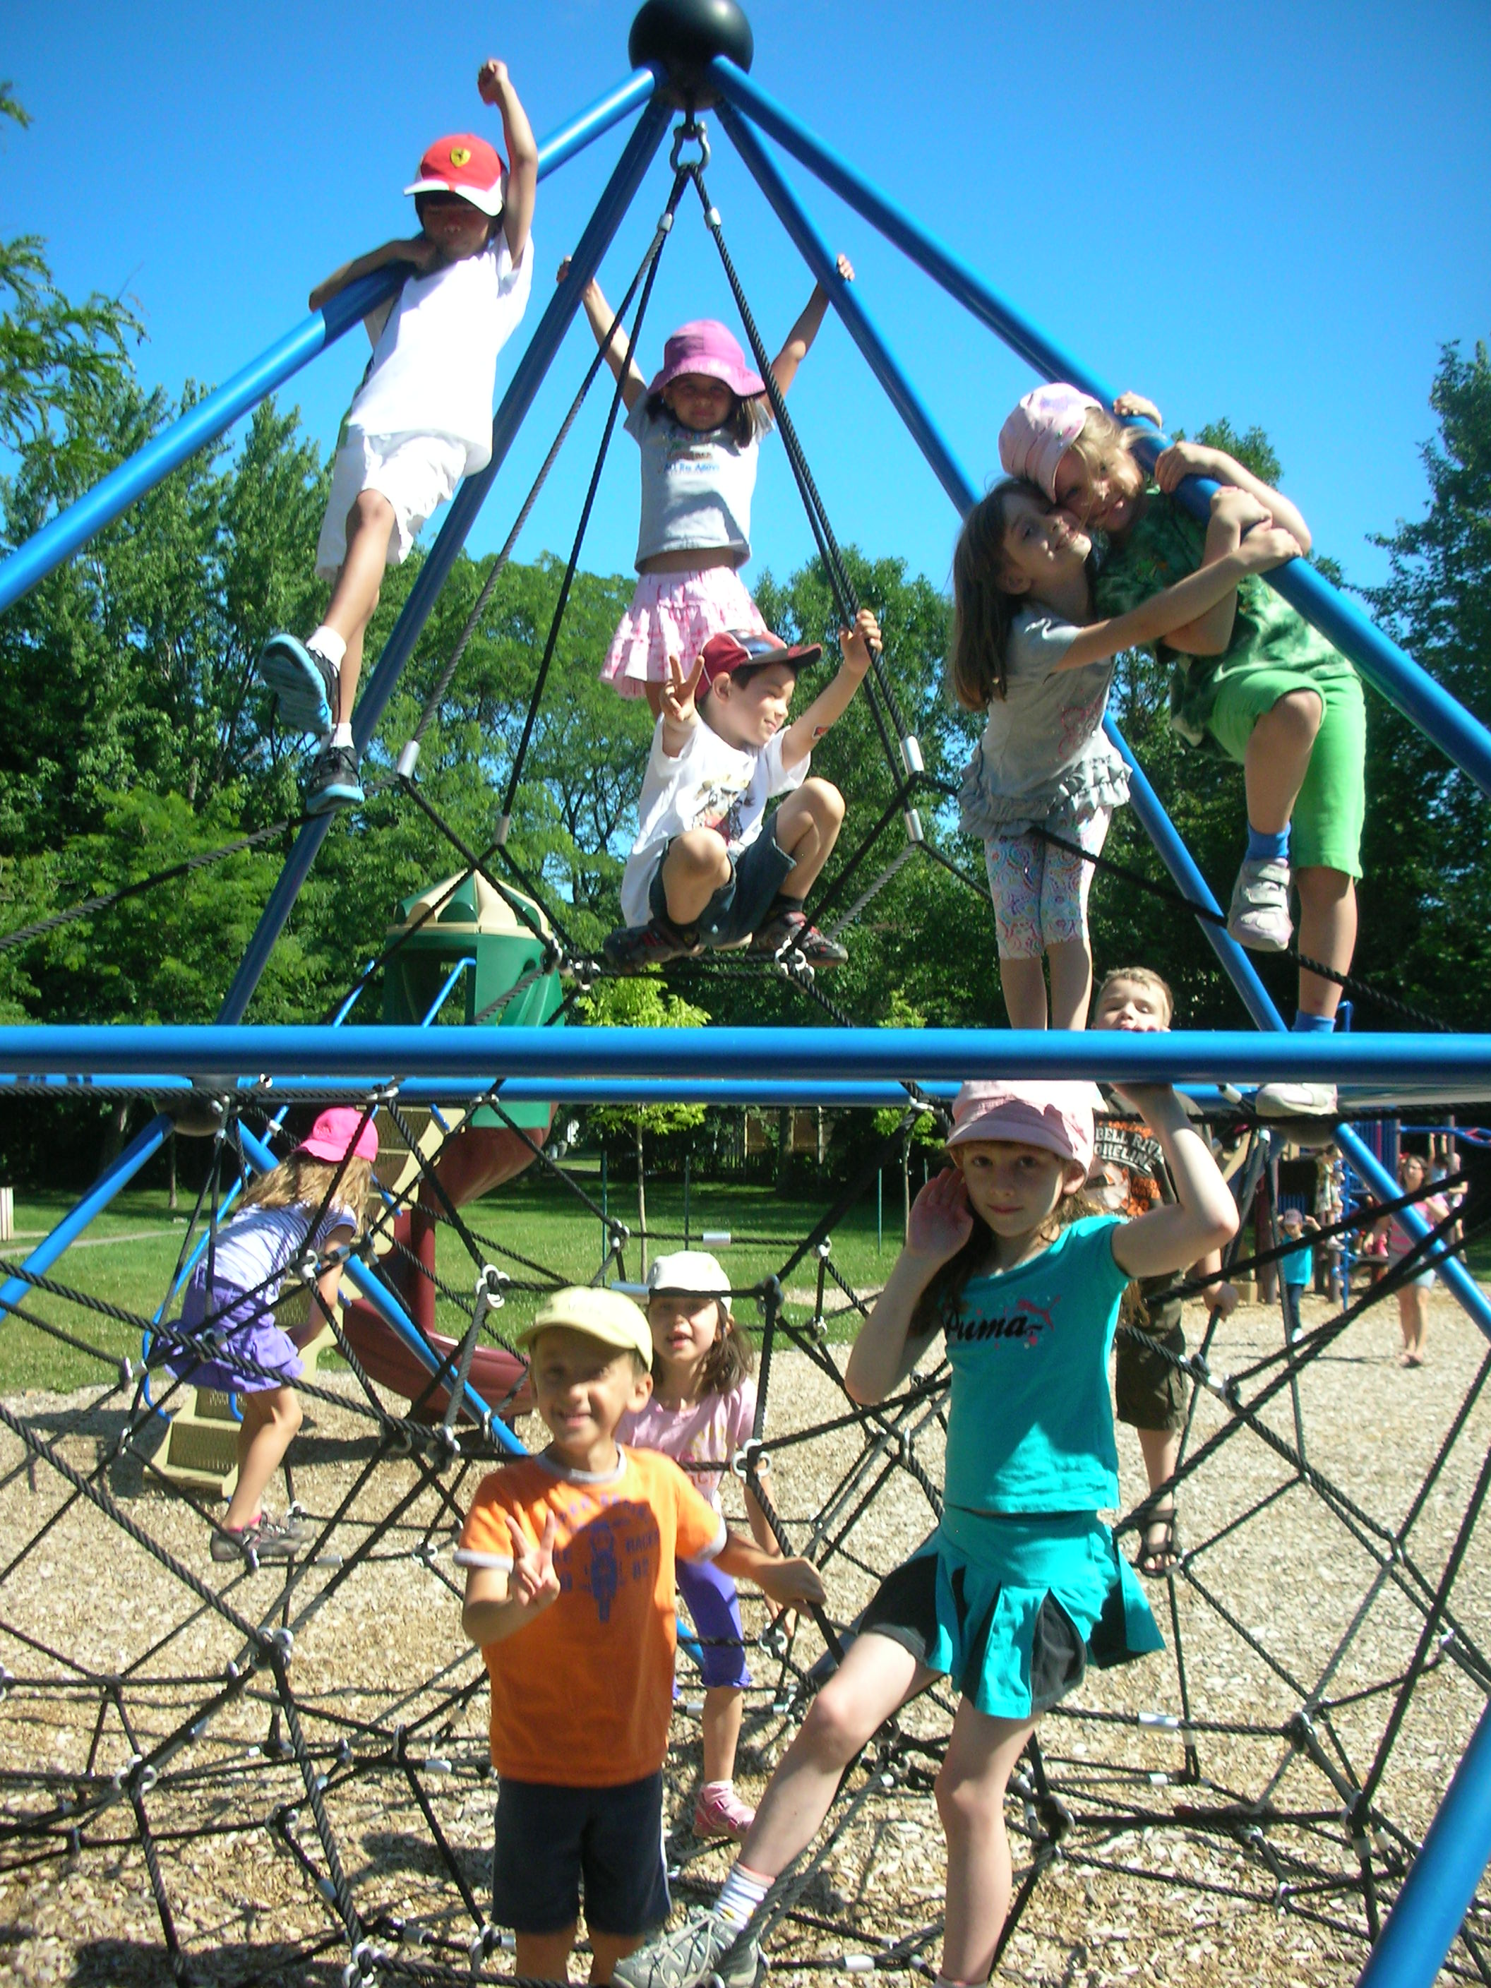
- If you would like more information or a tour of the facilities at Montessori Pointe Claire please call for an appointment at
- 514-697-3792 or email office@montessoripc.com

To register for summer camp please fill in and return along with your cheques (or indicate etransfer):
- The Montessori Summer Camp Registration Form
- The Swimming Lesson Registration Form (if your child will be taking swimming lessons)
- A Registration Contract (if you have not filled one out previously)
- Medical forms (if not previously done). These forms are available at our office and can be done the day of registration when you bring in your other forms.

116 Sunderland Ave., Pointe Claire, Que. H9R 1L2 514-697-3792
office@montessoripc.com www.montessoripc.com
www.montessoripc.com

MONTESSORI POINTE CLAIRE SUMMER CAMP- REGISTRATION FORM SENIOR CAMPERS

Using the calendars below, please circle the days your child will attend
IMPORTANT: circle each day individually: i.e. 3 4 5 6 7

JUNE/JULY AUGUST/SEPTEMBER
Mon Tue Wed Thu Fri Mon Tue Wed Thu Fri
25 26 3 4 5 6 7_
29 30 closed 1 2 3 10 11 12 13 14
6 7 8 8 10 17 18 19 20 21
13 14 15 16 17 24 25 26 27 28
20 21 22 23 24
27 28 29 30 31

Child’s name_______________________________________Date of birth_________________________

Present Classroom number (if applicable) ______________

I enclose the following cheques and associated forms.
 Registration fee if applicable: cheque dated today’s date: $50.00
 Payment for period of June 25 to July 10- cheque dated June 25, 2020:
_______# days total for June 25 to July 10= _______x $58.00 =$_____________
 Payment for period of July 13 to July 17- cheque dated July 13, 2020:
_______# days total for July 13 to July 17= _______x $58.00 =$_____________
 Payment for period of July 27 to August 7- cheque dated July 27, 2020:
_______# days total for July 27 to August 7= _______x $58.00 =$_____________
 Payment for period of Aug 10 to Aug 21- cheque dated Aug 10, 2020:
_______# days total for Aug 10 to Aug 21= _______x $58.00 =$_____________
 Payment for period of Aug 24 to Sept 4- cheque dated Aug 31, 2020:
_______# days total for Aug 19 to Aug 30= _______x $58.00 =$_____________
 Swimming lessons July 6 to 17 (10 days) - separate cheque dated July 1, 2020: $205 .00
 Swimming lessons Aug 3 to Aug 14 (10 days) - separate cheque dated Aug 1, 2020: $205 .00
Cheques are payable to “The Montessori School of Pointe Claire” and are to be given at the time of registration. Note: For swimming lessons please issue separate cheques.
OR INDICATE:  I will be paying by electronic transfer on the dates as shown above (etransfer@montessoripc.com) please indicate child’s name as a note on the transfer.
Please note: To request a change of dates or to cancel registration, 4 weeks’ notice is required.

Parents’ signature_______________________________________________

Telephone (h)______________________(w)______________________ (cell)______________________
116 Sunderland Ave., Pointe Claire, Que. H9R 1L2 514-697-3792
office@montessoripc.com www.montessoripc.com
www.montessoripc.com

MONTESSORI POINTE CLAIRE SUMMER CAMP
Swimming Lesson Registration

Senior Campers

Swimming lessons will take place at the Pointe Claire Aquatic Centre indoor pool, in the 25-meter, warm water “teaching pool”. The Pointe Claire Aquatic Centre is renowned for quality swimming lessons. If your child has taken lessons at the Aquatic Centre he/she will be placed in his already determined level. For those children who have taken lessons at another pool (or have never done lessons), you can fill in the form below to give us an idea of the level, however, at the first lesson the child will be assessed by the instructors to make sure he/she is placed correctly. The Aquatic Centre is located at the corner of Maywood and Douglas Shand roads. Transportation to the pool is by school bus. Swimming sessions are consecutive days (Monday to Fridays). Each session is a total of 10 days. There is a half-hour-swimming lesson given by the pool’s certified instructors, and a half-hour of supervised play in the wading pool. The children will be “in the water” from about 10:15 to 11:15 a.m. Registration is limited so please return your forms promptly.


I would like to register my child for swimming lessons
from  July 6 to 17, 2020 (10 lessons) Cost: $205.00
and/or  August 3 to August 14, 2020 (10 lessons) Cost: $205.00


Child’s Name ________________________________ Date of Birth ___________________

To help us with placement please check where appropriate for the child’s first session. If your child is attending both sessions, the August level will be determined by us after his/her July lessons. During the first lesson, each child will be assessed to determine that he/she is placed in the correct level.
IF YOU KNOW THE LEVEL: White  Yellow 
Green  Red 
OR, IF YOU DO NOT KNOW THE LEVEL check one of the following:
My child: cannot yet swim 
can swim with a floatation device (bubble/floaties) 
can swim one or two meters on his/her own 
can swim across the pool on his/her own (24meters) 
Please add any comments you think would be helpful for us to register your child in the correct level
_______________________________________________________________________________________
_______________________________________________________________________________________

Parents’ signature________________________________(In order to reserve your child’s spot in swimming lessons, please return this form with your registration)
116 Sunderland Ave., Pointe Claire, Que. H9R 1L2 514-697-3792
office@montessoripc.com www.montessoripc.com

