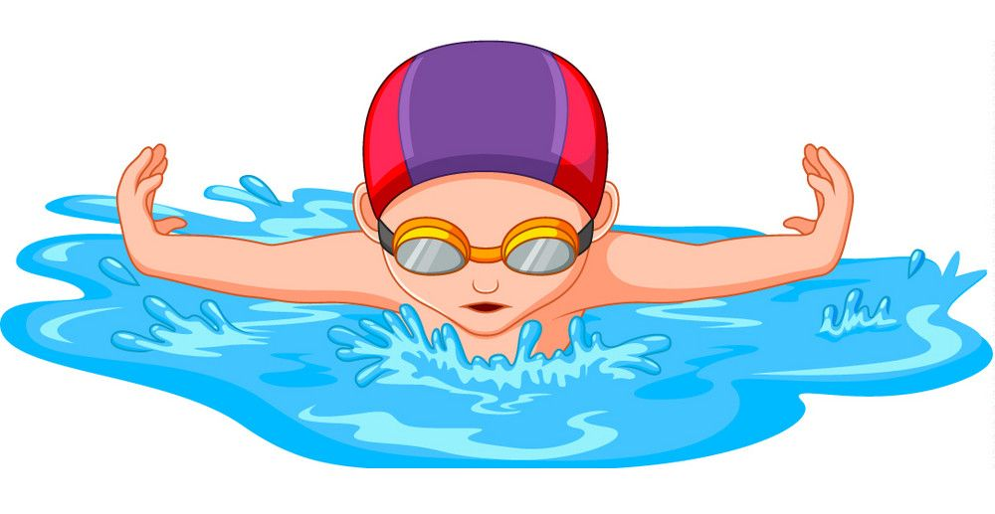
SWIM & GYM

WEDNESDAY, MARCH 18, 2020

CLASSROOM 1,2 and 3

This excursion takes place in the morning for some fun land and aquatic activities. The Pointe Claire Aquatic centre has a wonderful gymnasium and pool. For 30 minutes, children will explore movement in the gym through structured activities and games and then they have a wonderful ‘’30-minute swim”. The qualified and caring instructors provide each child with a swimming lesson and of course some time to play.

The Pointe Claire Aquatic Centre provides a safe and happy learning experience with the dynamic staff at the Pointe Claire pool. If your child does not usually attend on Wednesday and you would like him/her to come on the trip please see us in the office to confirm availability. Your child needs to wear a bathing suit with t-shirt on top and bring a towel (put names on the towels please).

TO REGISTER, PLEASE RETURN THE FORM BELOW.
Registration will be accepted on a first come-first serve basis.
⇒⇒⇒⇒⇒⇒⇒⇒⇒⇒⇒⇒⇒⇒⇒⇒⇒⇒⇒⇒⇒⇒⇒⇒⇒⇒⇒⇒⇒⇒⇒⇒⇒⇒⇒⇒⇒⇒⇒⇒⇒⇒⇒⇒⇒⇒⇒
Please register my child for Swim & Gym:
CHILD’S NAME __________________________Date of birth _________________
When: Wednesday, March 18. Two groups: Bus leaves at 9:00 and 10:00
Amount: $20.00 € cash
€ cheque (payable to Montessori Pointe Claire
and dated March 15, 2020)
€ etransfer (to etransfer@montessoripc.com
please include a note with the child’s name)

Parent’s Signature_________________________________Date__________________

